|  |  |
| --- | --- |
|  | **Pimpri Chinchwad Polytechnic, Nigdi, Pune - 44** |
| **-------------------------**  **ACAD/R/27/CO**  **Rev.00 Dt. 02-04-2013** | **-----------------------------------------------------------------------------------------**  **Computer Department (2017-18) w.e.f. 20-6-16**  **Final Year Project Synopsis Page 01 / 03** |

--------------------------------------------------------------------------------------------------------------------------

SMART METER WITH E-WALLET

PROJECT SYNOPSIS

OF MAJOR PROJECT

DIPLOMA IN

COMPUTER ENGNEERING

SUBMITTED BY

G-10

NAMES OF THE STUDENT

36. UTKARSH PRALHAD BHANGALE

46. VINAY NITIN SUDRIK

50. PRAFFUL PETER WANIA

15. SUMIT SUPRIYA BHATTACHARYA



PIMPRI CHINCHWAD POLYTECHNIC, NIGDI,

PUNE - 44

(Prof. Poonam Chavan) (Prof. M.S. Malkar)

**(Name and Sign. of Project Guide) (H.O.D.,CO Dept.)**

**Project Title: Smart Electricity Metering With E-Wallet**

**Introduction:**

With the great developments in the field of Internet and technologies, everything has become digital. Internet has become an important part of our lives. A new technology has entered into this picture known as Internet of Things (IoT). Internet of Things is a network comprises of many electronic devices and sensors which are connected together to exchange some information over the web. The devices based on IoT seem talking and sharing data with each other. Smart Meter is one of the applications of IoT. It records the consumption and sends the readings to the utility office on regular basis for monitoring and billing. For a long time, traditional electromechanical meters have been used. Meter readings were noted down on the monthly basis. But now with the evolution of smart electricity meters, things are changing

In this project we will be using the sensor which is fixed in the meter and the details of the units will be stored in the cloud and from the cloud the message will be send to the MSEB and to the user on the daily basis, and then the user can pay the bill by using the e-payment. By using this system the user can know how much light the particular device consumes in his or her home.

Also we add one more feature in it The Prepaid Energy Meter which allows user to use prepaid energy meter functionality. Using this functionality user will able to pay in advance and use the exact amount of energy.

The system starts with GSM modem Connection and first configures the user number and gives authority to that number. The system is made up of AVR Microcontroller, current sensors , GSM modem, LCD display ,energy meter and loads.

**Objective:**

The main objective is to automate the manual process of taking readings, calculating bills and then handing them to the user. All the process from calculating the exact use of electricity to paying the Bills to MSEB is made digital and can be automated. The main objective is to make the work of MSEB easier and hustle free.

**Literature survey:**

The paper titled *Internet of Things based Smart Electricity Meters* proposes a syste for smart meter. This paper proposes a new smart meter which need to be replaced. Thus all the old meters need to be replaced with this new meter. This is main drawback of the system. Another research paper titled *Smart Electricity Meter Data Intelligence for Future Energy Systems: A Survey*  presented the current smart-metering space as the smart-metering landscape, and then, a framework has been established to relate smart meter data to stakeholders and applications created by their needs and the analytics tools and techniques required to achieve the stakeholder needs.

In the existing system the particular person checks the meter units by manually going there clicking the photo of the meter and then calculating the amount according to the units, then they will send the bill to the user by post/by hand. So this whole process is so much lengthy and consumes a lot of time.

The proposed system not only automates the meter readings but also provide the user with facility of prepaid electricity bill payment. Thus it is more user friendly. Also the existing system need not to be replaced just the additional hardware needs to be installed in existing meters.

**Scope of the project:**

* The system will be used to provide bill to consumer both as an SMS along with other in-built features such as tamper proof, fault detection.
* The proposed energy meter utilizes a GSM module to transfer energy consumed to the authority side.
* Similarly authority side also uses these GSM service to send back the bill.
* Electricity bill will be automatically deducted from E-Wallet.
* Customers can recharge their meter through E-Wallet Facility.

**Architectural model (project block diagram):**

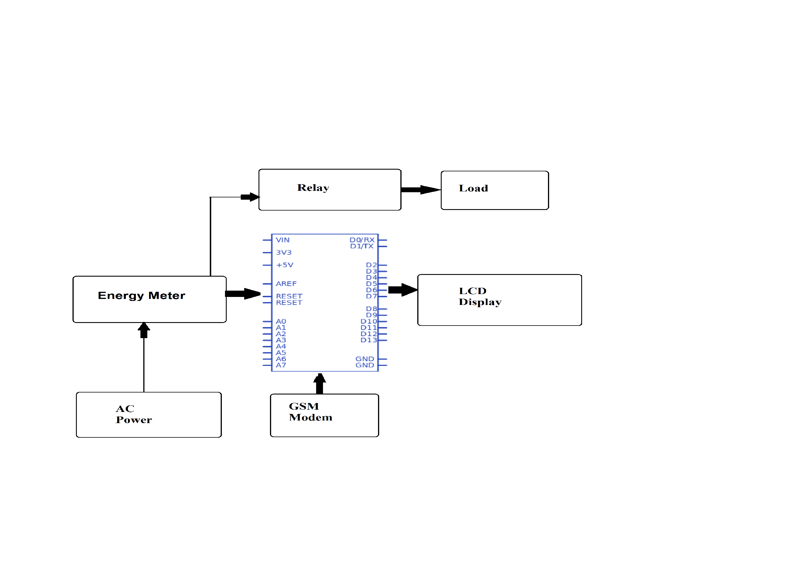

**Technical requirement:**

1. **Software Requirement**

* Arduino IDE
* Embedded C Programming Language:

1. **Hardware Requirement:**
   * Arduino Nano ATmega 328 Microcontroller
   * Current Sensor
   * GSM Modem
   * LCD Display
   * Energy Meter
   * Loads
   * Resistors
   * Capacitors
   * Diodes

**Advantages of project:**

* Saves the time.
* Easy to use.
* Fast processing.
* E-payment facility.
* Can know the light consume by each devise in our home.

**Limitations of project:**

* Transitioning to new technology and processes
* Managing public reaction and customer acceptance of the new meters
* Making a long-term financial commitment to the new metering technology and related software
* Managing and storing vast quantities of metering data.
* Ensuring the security of metering data.
* Paying additional fees for the new meter

**Conclusion**

The complete working model of a smart energy meter was built which uses existing GSM system And E-Wallet facility to recharge your meter. The model will satisfactorily work with home appliances. Automatic meter reading and billing can be explained well using the system. Financial losses of electricity board can be minimized. Labor charges and effort can be reduced. The error, time delay that occurs due to manual metering can be avoided to a great extent. Electrical line fault detection has been made easy for the electricity board. Finally but not the least this type of meter supports remote metering which is the future of energy meters. The smart meters will be part of a much wider IoT in the future integrating multiple aspects of human needs and services to satisfy such needs, and the analytics requirements discussed, such as big data, real time analytics, stream analytics, will need to be built into the processes and workflows for diagnostics in real time.

**References**

* Sudhish N George and Ashna K, GSM based automatic energy meter reading system with instant billing, IEEE publications for International Multi-Conference on Automation, Computing, Communication, Control and Compressed Sensing(iMac4s), 2013 ,March 2013, pp. 65-71.
* Syed Khizar Ali Zaidi, Design and implementation of low cost electronic prepaid energy meter, Proceedings of the 12th IEEE International Multitopic Conference, December 23-24,2008, pp 548-552.
* H G Rodney Tan,C H Lee and V H Mok, Automatic power meter reading system using GSM network ,The 8th International Power Engineering Conference (IPEC 2007) , pp. 465-469.
* A Geetha and Dr.K Jamuna, Smart metering system International Conference on Information Communication and Embedded Systems (ICICES), 2013, pp 1-5.
* Arghya Sarkar and S. Sengupta, A novel instantaneous power factor measurement method
* based on wavelet transform, IEEE Power India Conference, 2006,pp 1-6.